**Brooklyn torah gazette**

**For parshas yisro 5782**

Volume 6, Issue 18 (Whole Number 273) 20 Shevat 5782/ January 22, 2022

**Printed L’illuy nishmas Nechama bas R’ Noach, a”h**

For a free subscription, please forward your request to [***keren18@juno.com***](mailto:keren18@juno.com)

**The Reichmann Legacy,**

**Utilizing Wealth to Help**

**Develop Torah Institutions**

**By Daniel Keren**

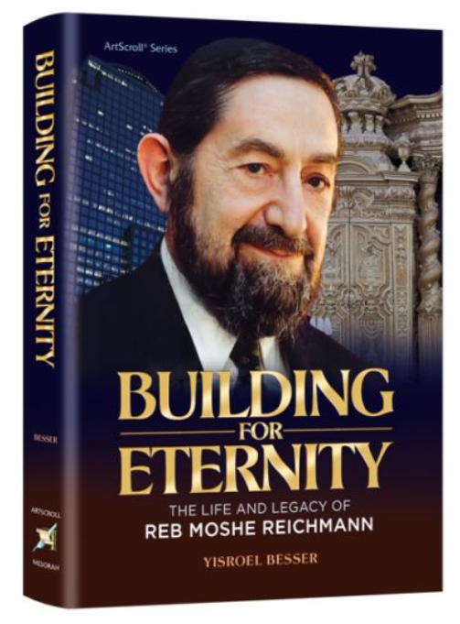

(Building for Eternity: The Life and Legacy of Reb Moshe Reichmann by Yisroel Besser, ArtScroll/Mesorah Publications, 302 pages, 2021

My daughter recently gave me a copy of the recently published ArtScroll book on the impressive legacy at one time of one of the world’s most wealthiest Orthodox Jews and perhaps simultaneously - the most generous baal tzedokah (philanthropist) to Torah causes around the world of all times – Reb Moshe Reichmann (known to the non-Jewish world as Paul Reichmann,) who with two of his brothers founded Olympia & York which at its height of glory in the 1980s and early 1990s had become the largest property development firm in the world.

Unlike other Orthodox Jewish titans in business and other important areas of public life, Reb Moshe always wore a yarmulka in meetings and when outside a distinguished homburg hat. Articles about him and his brothers, who at one time were the fourth wealthiest family in the world always highlighted the fact that their company’s building projects always stopped its work on Shabbos and Jewish holidays. Articles also highlighted how compared to other wealthy billionaires, Reb Moshe and his brothers lived in comfortable homes that were however not knock-out eye-catching luxury creations that would get written up in fancy architectural magazines.

**A Product of Committed Orthodox Parents**

The product of committed Orthodox parents – Reb Shmaya and Rivkah Reichmann, Reb Moshe was born in Vienna in 1930, the fifth of six children. His parents ran a successful egg business.

When several days before the Bar Mitzvah celebrations of their eldest son Eliyahu that was to be held in Vienna, Shmaya’s father Dovid suffered a stroke. The grandfather of the Bar Mitzvah boy was thus not able to come to Vienna to attend, so at the last minute Shmaya and his wife decided to take most of the family to their original hometown of Beled in Hungary so the grandfather, the family patriarch could take part in the simcha.

Hashgacha Pratis (Divine Providence) revealed itself by the fact that on that very Shabbos day when the Reichmanns were celebrating Eliyahu’s Bar Mitzvah in the grandfather’s village of Beled, the Nazis (yemach shemam) launched their deadly Anschluss with German troops invading Vienna and other parts of Austria that resulted in the annexation of Austria as a part of Germany and resulting in the immediate harassment of Jewish neighborhoods including the burning of Jewish stores and homes. Gestapo officers rushed in Vienna to catch Shmaya Reichmann whom they knew to be a wealthy businessman, but he was nowhere to be found.

**The Family Wound Up in Tangiers, Morocco**

Realizing that it would be impossible to return to Vienna after the Bar Mitzvah, the family wound up in Tangiers, Morocco where Reb Moshe’s mother threw herself into preparing and shipping food packages to be sent to Jews trapped behind German Nazi occupied Europe. Many who received those parcels and survived the war later testified that those packages helped them in numerous ways to avoid starvation.

After the Second World War, Reb Moshe left his family in Tangiers to learn Torah; first in the Pupa Yeshiva in Belgium under the guidance of Rav Yosef Grunwald and later in England at Rav Moshe Schneider’s Yeshivah Toras Emes in London and after that at Gateshead Yeshiva in Northeast England. He also went to Eretz Yisroel where he first learned at the Ponevezh Yeshiva in Bnei Brak and finally at the Mirrer Yeshiva in Jerusalem.

After his marriage in 1955 to Lea (nee Feldman), the couple went back to Reb Moshe’s adopted homeland of Morocco where he was asked to administer a series of Otzar HaTorah schools in the North African country that at one time had boasted a vibrant Jewish population.

**First Moved to New York City Before Coming to Toronto**

In 1956, he first moved to New York City which he and his wife did not find to his liking and then moved north to Toronto and joined his brothers who had established a tile company. That eventually evolved into the Olympia and York property development company that made Moshe and his brothers extremely wealthy and able to utilize a great portion of their profits to help build the Orthodox Torah community in Toronto and also generously benefit Torah institutions around the world, especially in Eretz Yisroel.

But the main focus of Yisroel Besser’s thoughtful profile on the late Reb Moshe Reichmann was how Mr. Reichmann successfully overcame the challenge that wealth has to all too often corrupt the spiritual core of a Jew and how even after the loss of most of his wealth with the collapse of Olympia and York due to financial tsunamis not in his control in the early 1990s, he didn’t lose faith in Hashem. Indeed, he made an impressive comeback financially and was to his last days before his petirah still able to donate generous funds to Torah institutions.

**Never Allowed His Wealth to Make Him Arrogant**

The book doesn’t focus on his incredible financial achievements such the creation of the World Financial Center in Manhattan or other important cities in North America or London; but rather how throughout his greatest days of business success he never became arrogant and always demonstrated consideration for others, even those who tried to take advantage of him.

“Building for Eternity” by Yisroel Besser can be found in Jewish bookstores or from the publisher or other Jewish book websites.

*Reprinted from this week’s edition of The Jewish Connection.*

**Rabbi Berel Wein**

**On Parshas Yitro**

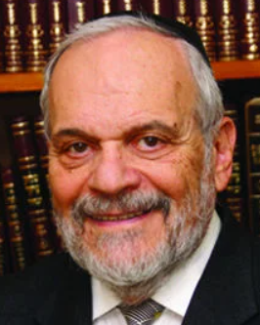

A literal reading of the Parsha tells us that Yitro, who was the high priest of Midian and the father-in-law of Moshe, saw of the events of the Exodus from Egypt and, according to Rashi based on Midrash, saw the battle the Jewish people fought against Amalek.

The Torah implies, and Rashi states openly, that upon hearing of these events, Yitro was propelled to leave his home, and to come into the desert to accompany the Jewish people, at least initially, on their travels through the Sinai desert. The Torah does not tell us how he heard about these events, but, apparently, they were of such earth-shattering proportions, that the news spread rapidly throughout the Middle East.

From the verses in the song of Moshe and the Jewish people, at the splitting of the waters of Yam Suf, it is obvious that Yitro was not alone in hearing about these wonderous events. The verse says that all the nations of the area were also astounded to hear of these miracles, and to realize that a new nation had been born from the slavery of Egypt. Yet, the reaction of the people in those countries and especially that of Amalek certainly differed greatly from the response of Yitro to the very same news.

The nations of the world chose either to oppose the news by attacking the Jewish people, or, mostly, to simply ignore it as not being worthy of their concern. People are so confirmed in their inertia that even when there is an event that obviously is historic and earth-shattering, but which would, at the same time, cause a reassessment of their own lives, attitudes, and policies, they will, in the main, either deny the news, besmirch the miracle, or ignore the matter completely.

It is to the credit of Yitro that he chose to act positively upon hearing of the events that occurred to the Jewish people in their exodus from Egypt. Of course, being the father-in-law of Moshe, he also had a personal vested interest in visiting his family, but, nevertheless, it must be recorded to his credit, that he uprooted himself to join the Jewish people in their travels through the desert.

One of the great tests in life is how one responds to news that is momentous and unexpected, that makes it necessary to change one's habits and life direction. Jews often piously – and I do not doubt their sincerity when they say it – put off momentous decisions until the Messiah arrives. But the little I know of human nature teaches me that even when the Messiah arrives, there will be many who will not be willing to change their life pattern, sell everything to join the Jewish people in the land of Israel, with all the accompanying hardships that inevitably will be involved.

People hear many things, many times very important things, but this knowledge does not necessarily imply that they are willing to act upon them in a positive and productive manner. Yitro is eternally privileged to have a portion of the Torah on his name because he heard and shortly thereafter, he acted.

*Reprinted from this week’s website of rabbiwein.com*

# Rav Avigdor Miller on

# On Tricks for Keeping Silent



**QUESTION: How does one succeed in keeping his mouth shut?**

**ANSWER:**,It depends on the circumstances. The first thing is that you have to think to yourself, “Where is the place where I have most danger of speaking?” You don’t speak when you’re by yourself. So you have to think about that. “What kind of company is the place where I’m most liable to speak?”

Let’s say you talk most at work. So now, when you’re entering your place of work, make up your mind that you’re going to make yourself a reminder. Take out a piece of string that you prepared for the purpose and tie it around your finger. And constantly look at that string to remind you to keep your mouth closed.

You should try that – it’s not so easy.  And after a while, you might even forget about the string. After a while, you might become so accustomed that you could be looking at the string and you’re still talking. You have to train yourself to react to the string. While you’re looking at the string, you have to say to yourself as follows: פִּי כְסִיל מְחִתָּה לוֹ – The mouth of a fool is his ruination (Mishlei 18:7). Say it to yourself again and again.

Who’s a fool?  If you open your mouth, you’re already a fool.  So פי כסיל – The mouth of the fool, מחתה לו – that’s his ruination. And if you want to save yourself from that, so keep your mouth closed. When you talk, your mind is melted down and goes through your mouth. You lose everything you have in your brains by talking. And therefore, make some sign for yourself.

Now, let’s say you talk too much at home – let’s say you’re a woman and when your husband comes from work you start haken ah tcheinik. He’s tired, he wants a rest; so make up your mind that you’re going to do something about that. Take a rubber band and put it around your thumb and make up your mind that you’ll keep the rubber band on as long as your husband is tired. If he’s well-rested and willing to listen, then you could remove it.

Do something mechanical to remind you.  By mechanical means, a person can help control his tongue and be successful in learning how to talk only what is most necessary.  Try it out. There’s no charge here for good advice.

*Reprinted from the January13, 2022 email of Toras Avigdor (Tape 720)*

**Thoughts that Count for Our Parsha**

*And all the people answered together and said, "All that G-d has spoken we will do*." (Exod. 19:8)

Instead of each individual answering, "I will do," the Jews all responded together, "We will do." Each individual Jew not only took upon himself to observe the Torah, but to be responsible for other Jews doing so. *(Chidushei HaRim)*

*Yitro, the High Priest of Midian, the father-in-law of Moshe, heard.* (Exod. 18:1)

The Torah already mentions earlier that Yitro was the High Priest. When the Jews left Egypt and the Sea split, the world witnessed the greatness of the Jews. People from all over wanted to convert and be a part of the great Jewish nation. Since their motivation was to share in the glory, and not a sincere love of Torah and Judaism, they were rejected. However, when Yitro decided to convert he could not be accused of seeking glory, because he had already held the exalted position of High Priest of Midian. *(Yalkut Haorim)*

*Reprinted from the Parshat Yitro 5757/1997 edition of L’Chaim.*

**Why Was Only Yitro Inspired**

**By the Miracle of the Sea Split**

**From the Talks of the Lubavitcher Rebbe**

**Rabbi Menachem Mendel Schneerson, Zt”l**

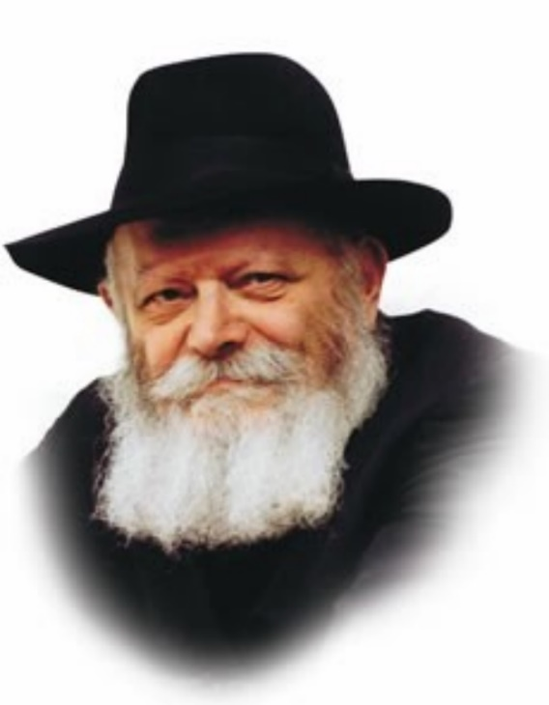

In this week's Torah portion, Yitro, we read: "And Yitro heard...everything that G-d had done for Moses and His people Israel...and Yitro came...to Moses into the wilderness."

What did Yitro hear that caused him to leave his land and join the Jewish people? As Rashi explains, he heard about the splitting of the Sea and the war against Amalek.

At first glance, this is surprising. The exodus from Egypt, with all its miracles, took place before the splitting of the Sea of Reeds; surely Yitro was aware of what happened. Why then was it not until the Sea was split and the battle fought against Amalek that he decided to go to Moses?

There is another difficulty as well. According to the principle that "one must always ascend in matters of holiness," one would expect the Jewish people to have reached a more elevated spiritual state by the time the Torah was given. The war against Amalek seems to represent a spiritual decline. However, as will be explained, the battle against Amalek was actually a significant ascent in the Jews' progression toward Mount Sinai.

When the Sea split, G-d's Divine light illuminated all planes of existence, effecting a bond between the higher spheres and the mundane physical world. All the nations heard of the great miracle; the revelation of G-dliness at the Sea struck fear in their hearts. Nevertheless, even after the splitting of the Sea, Amalek was not afraid to confront the Jews. Why? Because the revelation of holiness that occurred had still not purified the very lowest levels of the physical. These lowest levels became purified only after the battle with Amalek, when the Jews were victorious.

Thus, the war against Amalek was the final step in the Jewish people's preparation for receiving the Torah. For it was by means of this war that the entire world was transformed into an appropriate vessel to contain the Torah.

This also explains why these two events convinced Yitro to join the Jewish people: it was only after both had occurred that the world was completely ready to accept the Torah.

Each day we say: "Blessed are You... Who gives the Torah" -- in the present tense. Everyday, we receive the Torah anew. Just as our ancestors prepared themselves to accept the Torah at Sinai, so too must we prepare ourselves.

We do this by living with the adage "Know Him in all your ways." A Jew's connection to G-d must be constant, not just during prayer or Torah study. First comes the "splitting of the Sea" -- our involvement in spiritual matters, only after which can we wage "war against Amalek" and see to mundane affairs.

*Reprinted from the Parshat Yitro 5757/1997 edition of L’Chaim. Adapted from Likutei Sichot Vol 11.*

**More Parsha Thoughts**

*Aharon and all the elders of Israel came to eat bread with the father- in-law of Moshe.* (Exod. 18:12)

Moshe did not participate in this festive meal. After receiving the Torah, Moshe went up to heaven three times and came back the last time on Yom Kippur. On the following day he conveyed the Torah to the Jews. Since Moshe already knew about fasting on Yom Kippur, he couldn't participate in the meal, which took place on Yom Kippur. The rest of the Jewish people did not learn the Torah until the following day, and they were able to eat because they had not yet learned about the laws of fasting on Yom Kippur. *(Chidushei HaRim)*

*Reprinted from the Parshat Yitro 5757/1997 edition of L’Chaim.*

**Shtadlanim:**

**Elimelech Gavriel (Mike) Tress (1910-1967)**

**By Jonathan Rosenblum**

[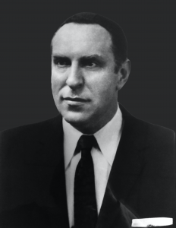](https://jewishaction.com/content/uploads/2021/11/MikeTress_Photo_135442-e1637095891881.png)

**Elimelech Gavriel (Mike) Tress**

**Courtesy of Agudath Israel of**

**America Archives**

It is one of history’s ironies that the Agudah movement in America came about almost entirely through the magnetic personality of a clean-shaven college graduate who never spent a day in any yeshivah. Mike Tress was twenty-one years old when he first walked into the Rodney Street branch of Zeirei Agudath Israel in 1931, after reading an article on Agudath Israel by Moreinu Yaakov Rosenheim, the world president, in the New York Public Library.

Within six months he had been elected president of the branch, over the strenuous objections of most of the older members. But as Louis Septimus, one of his original opponents, subsequently wrote, the older members who stayed away that night rendered a signal service by paving the way for the transformation of a shalosh seudos club into a world movement.

Gershon Kranzler, who had recently emigrated from Germany, became Mike’s closest assistant in building up Pirchei chapters across New York City, and then in other cities. He described the impact of Mike’s words on a small group of boys gathered for a melaveh malkah in a forlorn shul attic:

He addressed them, seriously and sincerely, and the ragged little children were lifted above their small, confining worlds. His sincerity struck home when he waved the magic wand of his “chaverim”. He made all of us, the Pirchim from East New York, the chaverim from the Bronx, the West Side, or Bushwick, feel like soldiers, recruited into the ranks of Hashem’s army, the Maccabees of today.

“He taught us that Judaism is not just a tradition, but our most precious possession, a possession for which he had to be prepared to fight and pay a price,” remembers Torah Vodaath’s Rav Moshe Wolfson. And when the remnant of the European Torah world began to arrive in America, they found a group of young American Jews who had been trained to look upon them as the true leaders of the Jewish people. Those youngsters were prepared to venerate the newcomers because their first hero had pronounced the names of the leaders of European Jewry, in forum after forum, year after year, with such awe and reverence.

**Many said of Mike that they never met someone who suffered as he did from another Jew’s pain, and those closest to him attest that he was never the same after what he had experienced in the DP camps.**

Above all, Mike channeled their youthful idealism into life-saving work. Zeirei Agudath Israel worked endlessly to procure visas for Jews trapped in Europe throughout the war, prepared the applications for seventy Special Visitors Visas, which brought to America leading roshei yeshivah, helped to procure thousands of fake South American passports, conducted endless fundraising campaigns (including closing the yeshivos for three days) in response to Rabbi Michoel Ber Weissmandl’s pleas for funds for his rescue schemes.

The six-foot-long forms for visas had to be typed out on manual typewriters, in quadruplicate, by young volunteers.

After the war, volunteers worked around the clock, including yeshivah students after night seder or returning from college night classes, packing cartons sent through the army post office to Orthodox soldiers in Europe for the she’eris hapleita in the DP camps. Some were still existing on less than 1,000 calories a day, and felt abandoned by world Jewry, even after the torments they had undergone.

Mike himself traveled to Europe under the auspices of UNRRA in late 1945 and spent more than a month with the she’eris hapleita, sleeping together with them on wooden pallets in extremely overcrowded lodgings. When he returned, he ignited a huge crowd—500 were turned away—with an account of his experiences and of his audience’s obligation to do everything possible to help them rebuild their lives.

[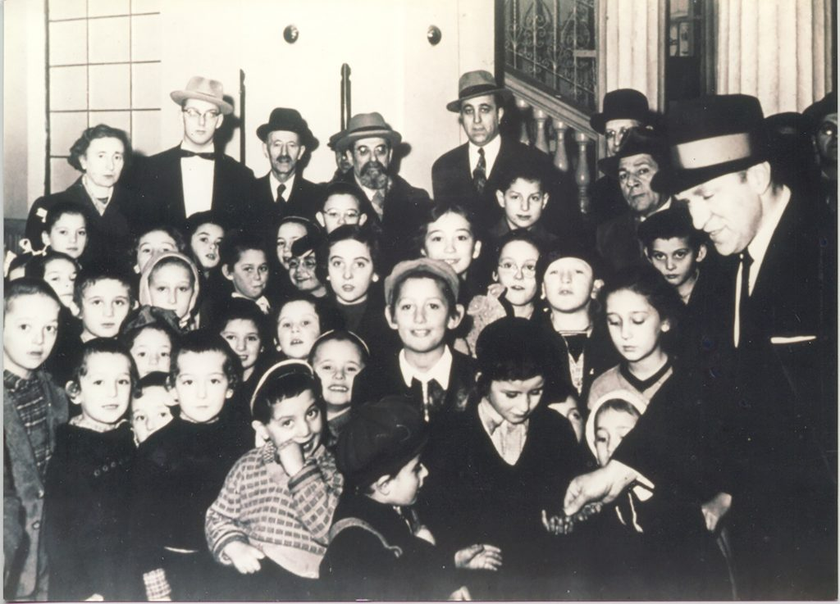](https://jewishaction.com/content/uploads/2021/11/Tress2.jpg)

Mike Tress (far right) with Hungarian refugees, December 1956. Courtesy of Agudath Israel of America Archives

Many said of Mike that they never met someone who suffered as he did from another Jew’s pain, and those closest to him attest that he was never the same after what he had experienced in the DP camps.

In 1939, Mike quit his job as an executive at S.C. Lamport, a large textile firm, to devote himself full-time to the rescue work of Zeirei. During one of Agudah’s recurring financial crises in the 1950s, an accountant appointed by the State of New York to review the organization’s books found that Mike had over seventeen years emptied his bank account, then sold off his stock portfolio, and finally mortgaged his home to fund the life-saving work of the Agudah, despite having a family of twelve children.

Toward the end of his life, he lacked the money for a heart operation, which offered his only hope of recovery. One of his daughters read in the paper that a shoe polish company of which he had been one-third owner had been sold for $3,000,000. “Think how different it would have been had you held on to those shares,” she remarked to her father.

Mike’s only response: “Baruch Hashem, how different.”

Jonathan Rosenblum is a journalist who writes for several Orthodox media publications, and has a weekly column in Mishpacha.

Reprinted from the Winter 5782 edition of Jewish Action, an OU (Orthodox Union) publication.